# What is The Linux Operating System & Its Features

An operating system is an interface between the user of a computer and the computer hardware. It is a collection of software that manages computer hardware resources and offers common services for programs of the computer. The short-term of the operating system is OS. And, it is an essential component of the system software in a computer system. The main purpose of an OS is to afford an environment in which a user can execute a program in an efficient or convenient manner. This article gives an overview of what is the Linux Operating System; the [types of operating systems](https://www.elprocus.com/different-types-of-computer-operating-systems/); their architecture and features.

Operating systems are categorized into six types based on the types of computers they control such as single-user single-task operating systems, real-time operating systems, single user, multitasking operating systems, multiuser operating systems, distributed operating systems, and embedded operating systems. The typical services that an operating system provides include a task scheduler, memory manager, disk manager, network manager, Other I/O services, and Security manager.

## What is the Linux Operating System?

Linux operating system is one of the popular versions of the UNIX operating system, which is designed to offer a free or low-cost operating system for personal computer users. It gained a reputation as a fast performing and very efficient system. This is a remarkably complete operating system, including a GUI (graphical user interface), TCP/IP, the Emacs editor, can X Window System, etc. The best Linux operating systems are Debian, Ubuntu, Fedora, Red Hat Linux, SUSE Linux, Gentoo, Kali Linux & Centos.

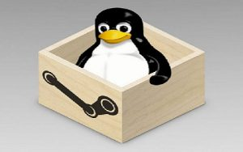Linux Operating System

The Linux Distributions are listed below.

* Debian Linux.
* Arch Linux
* Gentoo Linux.
* Kali Linux Distribution
* Ubuntu Linux.
* Fedora Linux Distribution.
* Linux Mint Desktop.
* OpenSUSE
* RHEL Linux Distribution.
* CentOS Linux Distribution.

### The History of LINUX Operating System

The History of Linux began in 1991 with the beginning of a personal project by a Finland student Linus Torvalds to create a new free operating system kernel. Since then, the resulting Linux kernel has been marked by constant growth throughout history.

* In the year 1991, Linux was introduced by a Finland student Linus Torvalds.
* Hewlett Packard UNIX(HP-UX) 8.0 was released.
* In the year 1992, Hewlett Packard 9.0 was released.
* In the year 1993, NetBSD 0.8 and FreeBSD 1.0 released.
* In the year 1994, Red Hat Linux was introduced, Caldera was founded by Bryan Sparks and Ransom Love and NetBSD1.0 Released.
* In the year 1995, FreeBSD 2.0 and HP UX 10.0 were released.
* In the year 1996, K Desktop Environment was developed by Matthias Ettrich.
* In the year 1997, HP-UX 11.0 was released.
* In the year 1998, the fifth generation of SGI Unix i.e IRIX 6.5, Sun Solaris 7 operating system, and Free BSD 3.0 was released.
* In the year 2000, the agreement of Caldera Systems with the SCO server software division and the professional services division was announced.
* In the year 2001, Linus Torvalds released the Linux 2.4 version source code.
* In the year 2001, Microsoft filed a trademark suit against Lindows.com
* In the year 2004, Lindows name was changed to Linspire.
* In the year 2004, the first release of Ubuntu was released.
* In the year 2005, The project, openSUSE began a free distribution from Novell’s community.
* In the year 2006, Oracle released its own distribution of Red Hat.
* In the year 2007, Dell started distributing laptops with Ubuntu pre-installed in it.
* In the year 2011, the Linux kernel 3.0 version was released.
* In the year 2013, Google Linux-based Android claimed 75% of the smartphone market share, in terms of the number of phones shipped.
* In the year 2014, Ubuntu claimed 22,000,000 users.

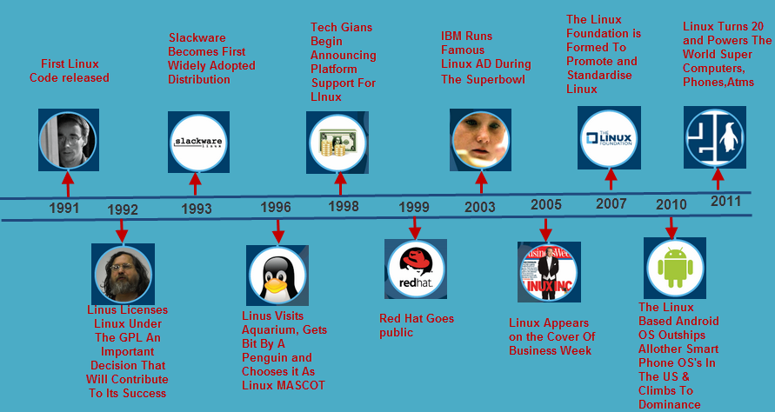The History of Linux

### Linux System Architecture

The Linux Operating System’s architecture primarily has these components: the Kernel, Hardware layer, System library, Shell, and System utility.

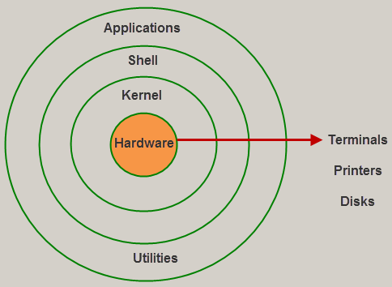Architecture of Linux

1). The kernel is the core part of the operating system, which is responsible for all the major activities of the LINUX operating system. This operating system consists of [different modules](https://www.elprocus.com/different-types-of-memory-modules-used-embedded-system/" \t "_blank) and interacts directly with the underlying hardware. The kernel offers the required abstraction to hide application programs or low-level hardware details to the system. The types of Kernels are as follows:

* Monolithic Kernel
* Microkernels
* Exo kernels
* Hybrid kernels

2). System libraries are special functions, that are used to implement the functionality of the operating system and do not require code access rights of kernel modules.

3). System Utility programs are liable to do individual and specialized-level tasks.

4). The hardware layer of the LINUX operating system consists of peripheral devices such as RAM, HDD, CPU.

5). The shell is an interface between the user and the kernel, and it affords services of the kernel. It takes commands from the user and executes the kernel’s functions. The Shell is present in different types of operating systems, which are classified into two types:command-line shells and graphical shells.

The command-line shells provide a command-line interface, while the graphical line shells provide a graphical user interface. Though both shells perform operations, the graphical user interface shells perform slower than the command line interface shells. Types of shells are classified into four:

* Korn shell
* Bourne shell
* C shell
* POSIX shell

### Features

The main**features of the Linux operating system** are

**Portable:** Linux operating system can work on different types of hardware as well as Linux kernel supports the installation of any kind of hardware platform.

**Open Source:** The source code of the LINUX operating system is freely available and,  to enhance the ability of the LINUX operating system, many teams work in collaboration.

**Multiuser:** Linux operating system is a multiuser system, which means, multiple users can access the system resources like RAM, Memory, or Application programs at the same time.

**Multiprogramming:** Linux operating system is a multiprogramming system, which means multiple applications can run at the same time.

**Hierarchical File System:** Linux operating system affords a standard file structure in which system files or user files are arranged.

**Shell:** Linux operating system offers a special interpreter program, that can be used to execute commands of the OS. It can be used to do several types of operations like call application programs, and so on.

**Security:** Linux operating system offers user [security systems](https://www.elprocus.com/anti-theft-security-system-for-cars/" \t "_blank) using authentication features like encryption of data or password protection or controlled access to particular files.

### How Does Linux be Different from other OS?

There are several features of the Linux OS that demonstrate that it is superior as compared to other OS. But, some other OS can be more helpful than Linux. The main major advantages of the Linux system include the following and that will decide why it is superior as compared to other operating systems.

* Open Source
* Heavily Documented for beginners
* Security
* Multiple Desktop Support
* Multitasking  
  Free
* Installation
* Lightweight
* Compatibility
* Stability
* Networking
* Performance
* Privacy
* Flexibility
* Community Support
* Software Updates
* Suitable for programmers
* Distributions/ Distros
* Graphical User Interface
* Live CD/USB

### Difference between Linux and Windows Operating System

The difference between Linux and Windows OS include the following.

|  |  |
| --- | --- |
| **Linux Operating System** | **Windows Operating System** |
| Linux is an open-source OS | Windows is not an open-source OS |
| The file name of Linux is case sensitive | The file name of Windows is case insensitive |
| It is free | It is commercial |
| In this OS, a monolithic kernel is used | In this OS, a microkernel is used |
| Linux is more efficient as compared to windows. | Windows is less efficient |
| To separate the directories, a forward slash is used | To separate the directories, the backslash is used |
| It is more secured | It is not secured as compared to Linux |
| Linux is extensively used to hack the systems | Windows do not offer much effectiveness in hacking. |
| Linux uses a hierarchical file system. | Windows uses several data drives namely C: D: E for the purpose of storing the files as well as folders. |
| The considered files in Linux are CD-ROMs, hard drives,  & printers | The considered devices in windows are Hard drives, printers, CD-ROMs. |
| The user account types in Linux are 3 types like  Regular, Root & Service Account | The user account types in Windows are four types like Administrator, Standard, Child, & Guest |
| The superuser like Root user of Linux includes all administrative human rights. | The administrator user of Windows includes all administrative human rights of computers. |
| The naming convention of Linux files is case-sensitive. So, two different files in this OS are sample & SAMPLE. | In Windows OS, you cannot have two files with the similar name within the same folder |
| For each user, his home directory is created like home or username. | In windows OS, the default home directory is My Documents |

#### Key Difference between Linux OS and Windows OS

The key difference between Linux and Windows include the following.

* Linux is an open-source OS, so the operator can easily modify source code according to the necessity whereas Windows is a commercial OS so the operator doesn’t have the right of entry to source code.
* Linux OS is much secured because it detects and fixes bugs whereas Windows OS has a vast user base, thus it turns into a goal of hackers to hit the windows system.
* Linux is faster as compared to windows even with older hardware
* Linux peripherals are considered like files whereas, in Windows, these are considered as devices
* The files in Linux have the same name within a similar dictionary whereas, in windows, it cannot have two files with a similar name within a similar folder.
* In Linux, the program files and the system can be found within dissimilar dictionaries whereas, in Windows OS, the program files & system are generally saved in a C drive.

### Linux Operating System Commands

The list of Linux commands is discussed below.

* adduser – Add a new user
* info – Help info
* id – Print user and group id’s
* arch – Print machine architecture
* chown – Change the user and group ownership of files
* hostname – Print or set system name
* head – Output the first part of the file(s)
* awk – Find and Replace text within file(s)
* chroot – Change the root directory
* cksum – Print CRC checksum and byte counts
* clear – Clear terminal screen
* chmod – Change the access permissions of files and directories
* bc – An arbitrary precision calculator language
* chkconfig – tool for maintaining the /etc/rc[0-6].d directory hierarchy
* cal – Display a calendar
* du – Estimate file space usage
* chgrp – Change the group ownership of files
* dirname – Convert a full pathname to just a path
* dircolors – Colour setup for `ls’
* cat – Concatenate files and print on the standard output
* dir – Briefly list directory contents
* chdir – Change working directory
* diff3 – Show differences among three files
* cmp – Compare two files
* diff – Display the differences between two files
* comm. – Compare two sorted files line by line  copy a file
* df – Display free disk space
* cp – Copy one or more files to another location
* dd – Data Dump – Convert and
* dc – Desk Calculator
* gawk – Find and Replace text within file(s)
* gzip – Compress
* cron – Daemon to execute scheduled commands
* date – Display or change the date & time
* crontab – Schedule a command to run at a later time
* cut – Divide a file into several parts
* csplit – Split a file into context-determined pieces
* env – Display, set, or remove environment variables
* fdformat – Low-level format a floppy disk
* grep – Search file(s) for lines that match a given pattern
* echo – Display message on screen
* format – Format disks or tapes
* fold – Wrap text to fit a specified width
* fmt – Reformat paragraph text
* ed – A line-oriented text editor (edlin)
* find – Search for files that meet the desired criteria
* fgrep – Search file(s) for lines that match a fixed string
* egrep – Search file(s) for lines that match an extended-expression
* eject – Eject CD-ROM
* fdisk – Partition table manipulator for Linux
* expand – Convert tabs to spaces
* false – Do nothing, unsuccessfully
* free – Display memory usage
* factor – Print prime factors
* fsck – Filesystem consistency check and repair or decompress named file(s)
* expr – Evaluate expressions
* grep – Search file(s) for lines that match a given pattern
* groups – Print group names a user is in

### Advantages

The **advantages of the Linux operating system** include the following.

* Similar to other operating systems like macOS and Windows, Linux is an open-source OS.
* It is not limited simply to the OS but it is also used as a platform to function servers, embedded systems, and desktops.
* Linux gives different distributions as well as differences because it is open-source as well as includes a modular design.
* Linux is used almost in every field like cars, home appliances, smartphones, servers, etc.

#### Applications of Linux Operating System

Nowadays, Linux is a multi-billion dollar industry. Thousands of companies and governments around the world are using Linux OS due to affordability, lower licensing fees,s and time and money. Linux is used in a number of electronic devices, which are available for consumers worldwide. The list of some popular [Linux based electronic devices](https://en.wikipedia.org/wiki/Category:Linux-based_devices" \t "_blank) includes:

* Dell Inspiron Mini 9 and 12
* Garmin Nuvi 860, 880, and 5000
* Google Android Dev Phone 1
* HP Mini 1000
* Lenovo IdeaPad S9
* Motorola MotoRokr EM35 Phone
* One Laptop Per Child XO2
* Sony Bravia Television
* Sony Reader
* TiVo Digital Video Recorder
* Volvo In-Car Navigation System
* Yamaha Motif Keyboard

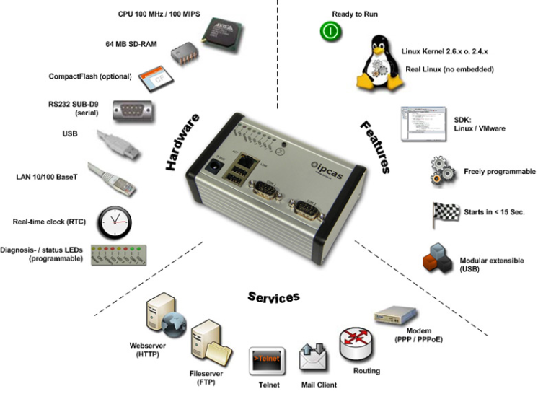Linux Applications

**Linux tools**

**Learn about different tools, tips, programs and resources from every genre of Linux tools, and learn how to deploy and configure the tools that suite your needs.**

**Application server administer tools**

Application server administration tools are designed to help administrators deploy, build up, and carry out all application operations between an organization's backend databases and the users. Application servers are software engines that deliver applications to client computers and devices while handling a good amount of the business logic and data acess of the application. LAMP (Linux, Apache, MySQL, and PHP) is a stack software solution that provide a way to deploy rich Web 2.0 applications on inexpensive clusters of service computers. Java Platform, Enterprise Edition (J2EE) application server is another open source application server, along with it's commercial open source counterpart, Red Hat's JBoss appserver. Others include Apache Application Server, Perl Server, and Enterprise JaveBeans. Learn how to manage these applications and how to use them to your advantage within your Linux system.

.

Additional application server administer tools:

[Dynamic Languages Powered by GlassFish v3 Application Server](http://java.sun.com/javaone/2009/articles/gen_dynamicglassfish.jsp)  
GlassFish v3 is an open source multilanguage application server with support for many Web frameworks, including Grails, Rails, Merb, Sinatra, and Django.

[Get Nagios for your Ajax applications](http://www.ibm.com/developerworks/web/library/wa-aj-nagios/index.html?ca=dgr-lnxw16wa-aj-nagios&S_TACT=105AGX59&S_CMP=GRsitelnxw16)  
Ajax applications must be monitored remotely over the networks. One program that can do this is Nagios, an open source host, service, and network monitoring program.

[Apache Web server tools](http://www.apache-tools.com/search.jsp?category=Web+Server&headerlf2=Web+Server&no_head=1)  
A comprehensive list of Apache Web server resources and tools.

[Ubuntu 8.04 (Hardy Heron) LAMP server setup](http://www.ubuntugeek.com/ubuntu-804-hardy-heron-lamp-server-setup.html)  
Installing a LAMP (Linux, Apache, MySQL and PHP) server on Ubuntu 8.04 can be done in 15 minutes.

[JBoss application server Wiki](http://www.jboss.org/community/wiki/Main)  
All things JBoss including hints for JBoss on Linux, an admin guide, and configuration instructions.

**Network tools**

OpenSSH, Nagios, and Autofocus are just a few examples of Linux network tools. Linux network tools consist of network performance monitoring, routing, and connectivity tools used on the Linux network. These tools help improve network performance and reduce downtime, configure routers, secure tunnels, and access network areas outside your local LAN.

Network tools help improve network performance and reduce downtime, as well as configure routers, secure tunnels, and access network areas outside your local LAN..

**Scripting tools**

Linux features powerful scripting languages like Bash, PHP and Perl, thus demanding scripting tools to execute script commands. Shell scripts allow several commands that would be entered manually at a command line to be executed automatically and quickly. Administrators and users use shell scripting tools to improve backup runs, purge /tmp directories, monitor processes and create users, among many other tasks. Some applications are written in shell script, and some users rely on shell scripts for installation or integration purposes. Shell customization, the list command, and hex codes are all scripting tools that can help improve the quality, security, or performance of the shell script.

Administrators and users use shell scripting tools to improve backup runs, purge /tmp directories, monitor processes and create users, among many other tasks.

**Mozilla**

Mozilla tools are used to improve the performance, optimization, and security of the Mozilla platform, a free, open source browser and set of applications descended from the Mozilla Application Suite. With the Mozilla platform and Mozilla tools, IT shops can better handle quick hats and desktop business process tasks, as well as Windows-to-Linux migrations and interoperability. Mozilla tools consist of the browser, e-mailer, composer, and the DOM Inspector and JavaScript debugger in the Web space.

Read tips on migrating from Internet Explorer to Firefox, discover how to detect against threats to your Firefox browser, and find out how to get the most out of your Mozilla Application Suite on Linux.

[Mozilla executives address Firefox's challenges](http://news.cnet.com/8301-13860_3-10251339-56.html)  
In this article, Mozilla executives argue there is still room for Firefox among competitors such as Apple and Microsoft.

**Security tools**

Linux security tools are developed to defend and protect your Linux platform. Vulnerability scanning, monitoring, and intrusion-detection tools are all security tools you can implement that can protect your Linux platform from hackers, malicious code, and inappropriate use. Snort, Nessus, Netstat, OSSIM and Bastille Linux are all tools that can shield your system.

The resources, tips, and articles below highlight many popular and effective monitoring, intrusion detection, and other security tools available to make your Linux distribution as safe and secure as possible.

[Linux security may be improved with hardening tool](http://www.computerworlduk.com/technology/security-products/prevention/news/index.cfm?newsid=4646)  
Learn more about Security Blanket, a Linux hardening tool that is designed to be easy to use and aid administrators with compliance issues.  
  
[In latest release, Nmap looks better than ever](http://www.linux.com/archive/feature/125894)  
The 4.50 release of the Linux security tool Nmap includes Zenmap, a cross-platform GUI front end that makes the tool easier to use.

**Management and administration tools**

Management and administration tools cater specifically to the Linux manager and administrator. These tools help administrators complete tasks such as monitoring Linux activity with performance reporting commands, implementing integrated remote control with remote management tools, and using Webmin to ease DNS management. Other management and administration tools used to simplify these duties consist of Nagios, top, and Puppet.

**Desktop tools**

The final featured category featured in our learning guide are desktop tools. From desktop virtualization tools to the latest OpenOffice upgrade, these desktop tools improve the performance, security features, and accessibility of the Linux desktop and Linux enterprise desktop.

Visit these different resources and Web sites to read about the benefits Linux desktop offers has over Windows and how to keep it this way with interoperability, desktop virutalization solutions, and other tools.